* Proposes an innovative way to control Home Appliance.
* The advantage of the proposed method is scalability and it’s a low-cost solution.
* As a result of this approach, there is power saving.
* Future Scope, apply this into smartwatch and failsafe system.

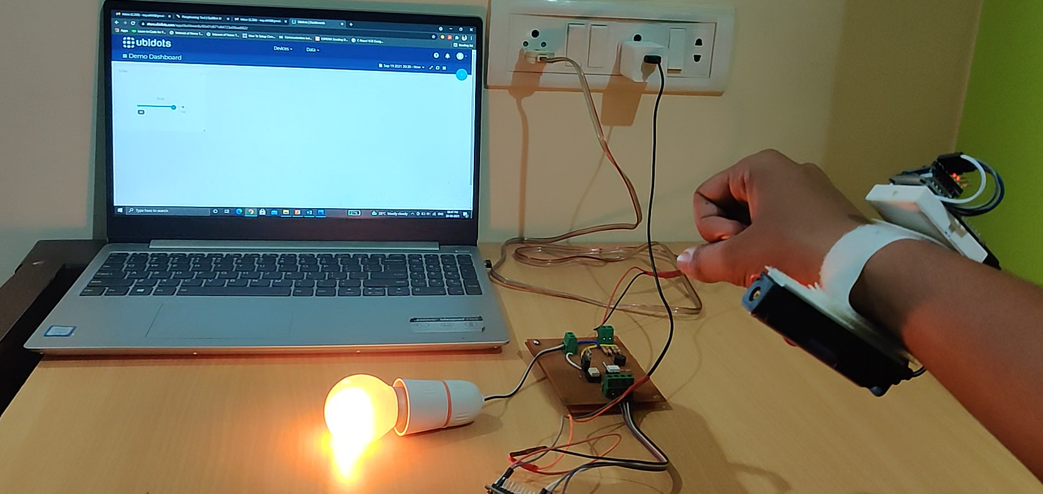

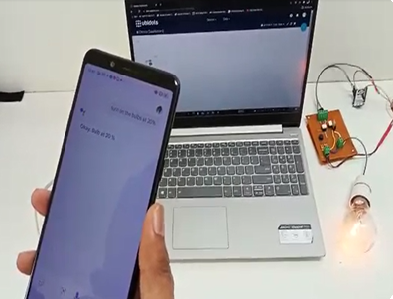

RESULT AND CONCLUSION

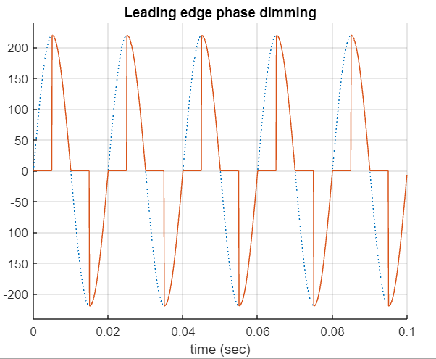

* Various input methods such as voice using google assistant, slide bar using ubidots server and based on our gesture with the help of an accelerometer.
* Includes a smart band which helps in controlling the intensities of devices taking hand gestures as input.
* MQTT protocol is used as the communication protocol in this model.
* The values from the wristband and google assistant which are the publisher is sent to the MQTT broker.
* The MQTT broker then sends the value to the subscriber. circuit

ANALYSIS

IMPLEMENTATION

MOTIVATION

* The subscriber circuit is divided into two parts Zero crossing detecting circuit and phase/angle control using triac.
* The output of the circuit shows that there is power as the power is provided only for certain amount of time.

THEORY

* Leading edge phase dimming method and MQTT protocol was used to complete the project.
* The MQTT protocol has 3 entities: broker, publisher and the subscriber and we are able to control the intensity of home appliances using this method.
* Develop a wrist band to control devices.
* Make it self-regulating for

Physically handicapped and old people.

* To make it relatively affordable, simple to implement and users friendly.

**INTENSITY CONTROL OF HOME APPLIANCES**

**USING MQTT PROTOCOL**

ROHAN N, AKHIL V, ROSHAN N, MRIDHULA S,

PROJECT GUIDE: DR. ANURADHA M



